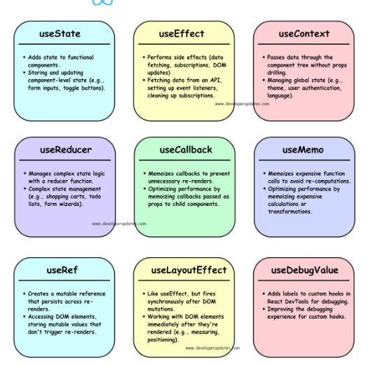

UseState

The useState() hook is one of the most commonly used React Hooks. It allows functional components to create and manage state (data that changes over time). Whenever the state changes, React automatically re-renders the component to display the updated UI.

const [state, setState] = useState(initialValue);

Explanation
- state → Current value of the state.
- setState → Function used to update the state.
- initialValue → Initial value assigned to the state.

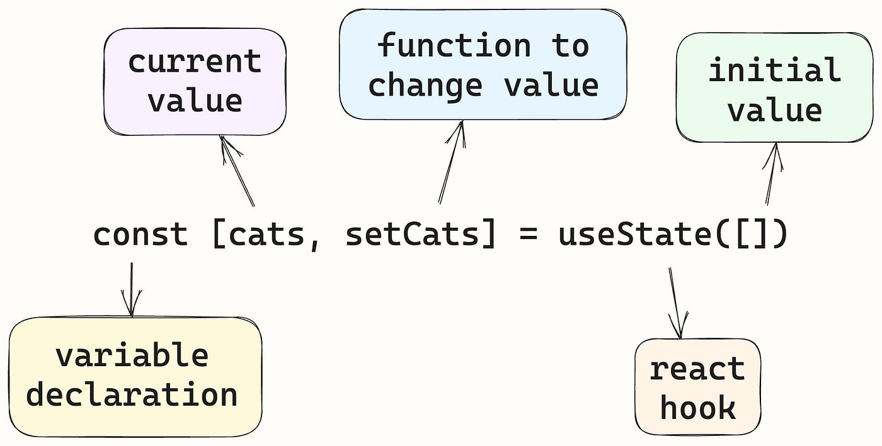

useEffect
The useEffect() hook is a React Hook that allows you to perform side effects in functional components. Side effects are operations that interact with things outside the component rendering process, such as fetching data, calling APIs, updating the document title, setting timers, or adding event listeners.

We use useEffect() to:
- Fetch data from an API
- Update the page title
- Start timers (setInterval, setTimeout)
- Add or remove event listeners
- Perform actions after a component renders

Syn:
useEffect(
() => { // Side effect code }, [dependencies]);
Explanation
- useEffect() → React Hook used for side effects.
- Callback Function → Contains the code to execute.
- Dependency Array → Controls when the effect runs.

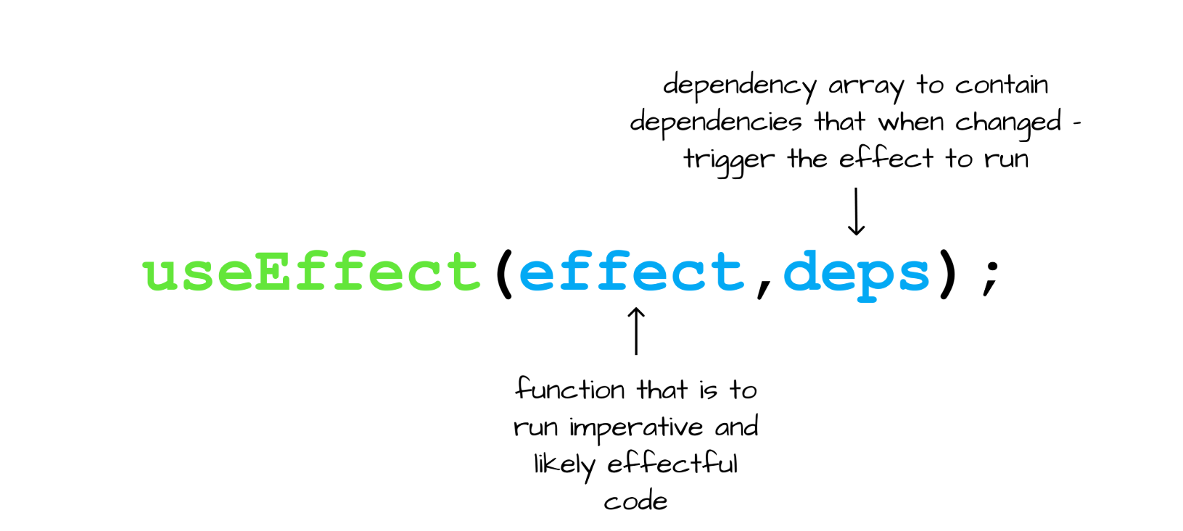

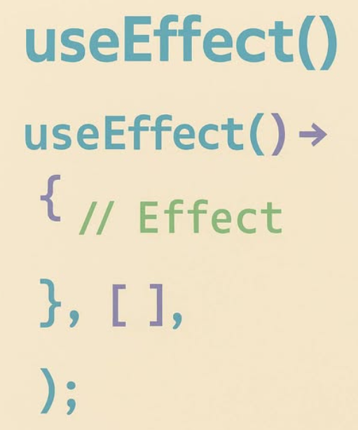

useRef
The useRef() hook is a React Hook that allows you to create a mutable reference that persists across component re-renders. It is commonly used to access DOM elements directly or store values without causing the component to re-render.
We use useRef() to:
- Access DOM elements directly
- Focus an input field
- Store previous values
- Store timer or interval IDs
- Persist values between renders without re-rendering the component

const refName = useRef(initialValue);
Explanation
- useRef() → Creates a reference object.
- initialValue → Initial value of the reference.
- ref.current → Holds the current value of the reference.
Access an Input Field

<input type="text" ref={inputRef} placeholder="Enter Name" />
<button onClick={focusInput}> Focus Input </button> </> ); }
export default App;

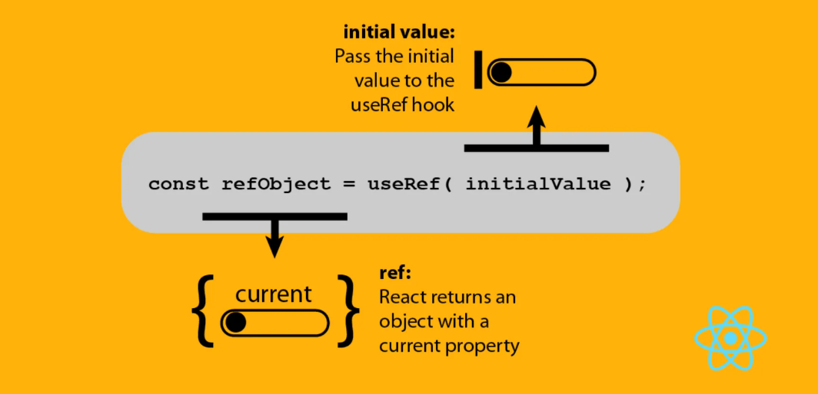

useContext

he useContext() hook is a React Hook that allows you to share data between components without passing props manually. It is commonly used to avoid prop drilling, where props are passed through multiple intermediate components.
We use useContext() to share common data across multiple components, such as:
- Logged-in user information
- Theme (Light/Dark Mode)
- Language settings
- Authentication status
- Application-wide settings

Steps to Use useContext()
- Create a Context.
- Wrap components with a Context Provider.
- Access the Context using useContext().

Syntax
Step 1: Create Context
import { createContext } from "react";

const UserContext = createContext();

Step 2: Provide Context
<UserContext.Provider value={value}>
<Child />
</UserContext.Provider>

Step 3: Consume Context
import { useContext } from "react";

const value = useContext(UserContext);

Example 1: Basic useContext()
App.jsx
import { createContext } from "react";
import Child from "./Child";

export const UserContext = createContext();

function App() {

return (
<UserContext.Provider value="John">
<Child />
</UserContext.Provider>
);
}

export default App;

Child.jsx
import GrandChild from "./GrandChild";

function Child() {

return (
<>
<GrandChild />
</>
);
}

export default Child;

GrandChild.jsx
import { useContext } from "react";
import { UserContext } from "./App";

function GrandChild() {

const user = useContext(UserContext);

return (
<h2>Welcome {user}</h2>
);
}

export default GrandChild;

Output
Welcome John

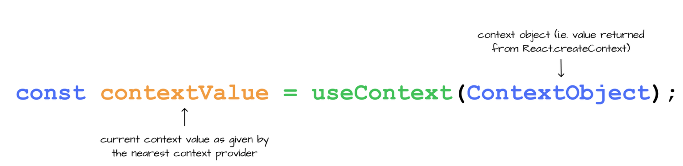

useReducer

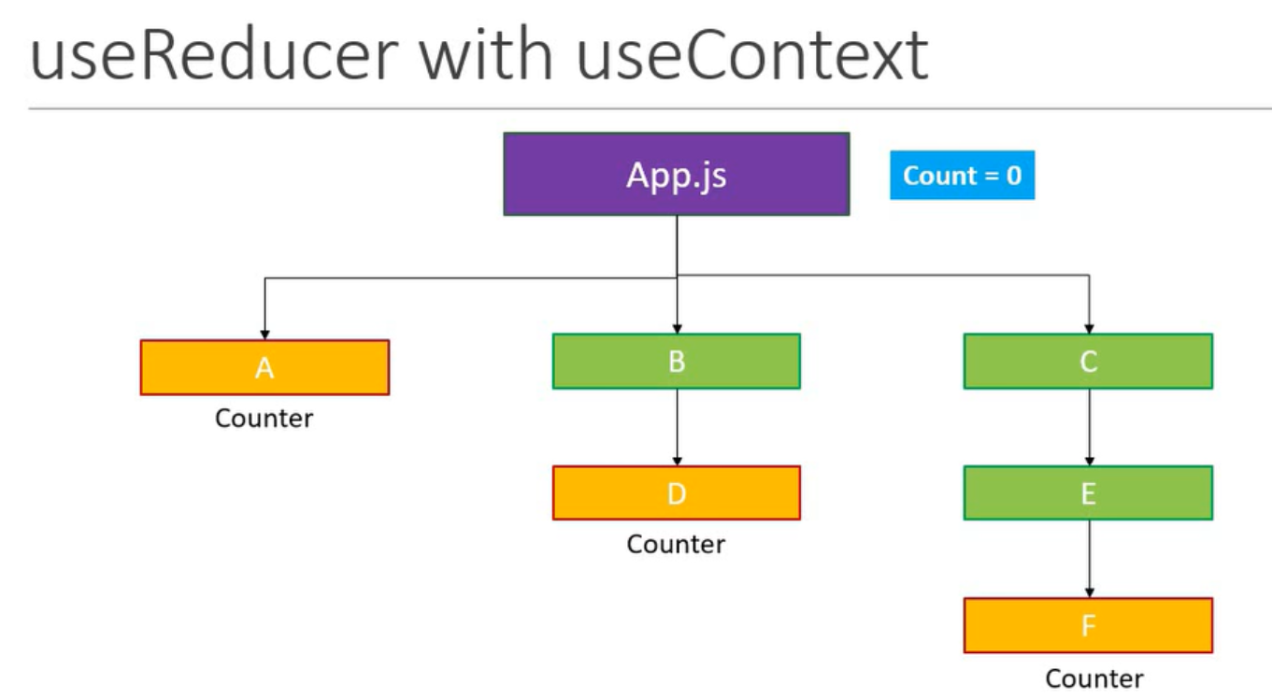

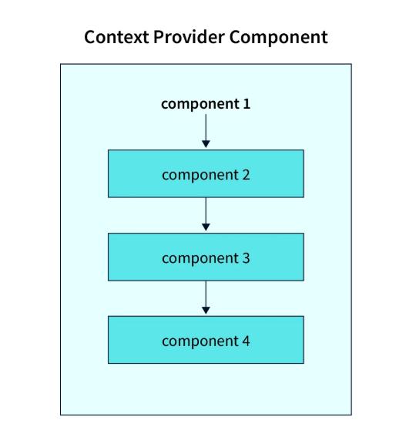

useMemo

